**LAPORAN SEMENTARA**

**PRAKTIKUM SINYAL SISTEM**

**PRAKTIKUM 2. PEMBANGKITAN SINYAL KONTINYU**

**Nama : Lubis Auliyak**

**Kelas : 2 D3 Telekomunikasi B**

**NRP : 1203191052**

1. **Percobaan 1 : Pembangkitan Sinyal Waktu Kontinyu Sinusoida**

Program Editor :

Fs=100;

t=(1:100)/Fs;

s1=sin(2*pi*t*5);

s21=sin(2*pi*t*10);

s22=sin(2*pi*t*15);

s23=sin(2*pi*t*20);

s31=5*sin(2*pi*t*5);

s32=10*sin(2*pi*t*5);

s33=15*sin(2*pi*t*5);

s34=20*sin(2*pi*t*5);

s41=2*sin(2*pi*t*5+pi/2);

s42=2*sin(2*pi*t*5+pi/4);

s43=2*sin(2*pi*t*5+pi*3/2);

s44=2*sin(2*pi*t*5+pi);

figure

plot(t,s1)

title('Pembangkitan Sinyal Waktu Kontinyu Sinusoida')

xlabel('time (sec)')

ylabel('x(t)')

legend('Sinyal Awal')

grid

figure

subplot(2,1,1)

plot(t,s21)

title('Perubahan Nilai Frekuensi')

xlabel('time (sec)')

ylabel('x(t)')

legend('f = 10Hz')

grid

subplot(2,1,2)

plot(t,s22, t,s23)

xlabel('time (sec)')

ylabel('x(t)')

legend('f = 15Hz','f = 20Hz')

grid

figure

subplot(2,1,1)

plot(t,s31, t,s32)

title('Perubahan Nilai Amplitudo')

xlabel('time (sec)')

ylabel('x(t)')

legend('Amp = 5','Amp = 10')

grid

subplot(2,1,2)

plot(t,s33, t,s34)

xlabel('time (sec)')

ylabel('x(t)')

legend('Amp = 15','Amp = 20')

grid

figure

subplot(2,1,1)

plot(t,s41, t,s42)

title('Perubahan Nilai Fase Awal')

xlabel('time (sec)')

ylabel('x(t)')

legend('Fase Awal = 90','Fase Awal = 45')

grid

subplot(2,1,2)

plot(t,s43, t,s44)

xlabel('time (sec)')

ylabel('x(t)')

legend('Fase Awal = 120','Fase Awal = 180')

grid

Output Program :

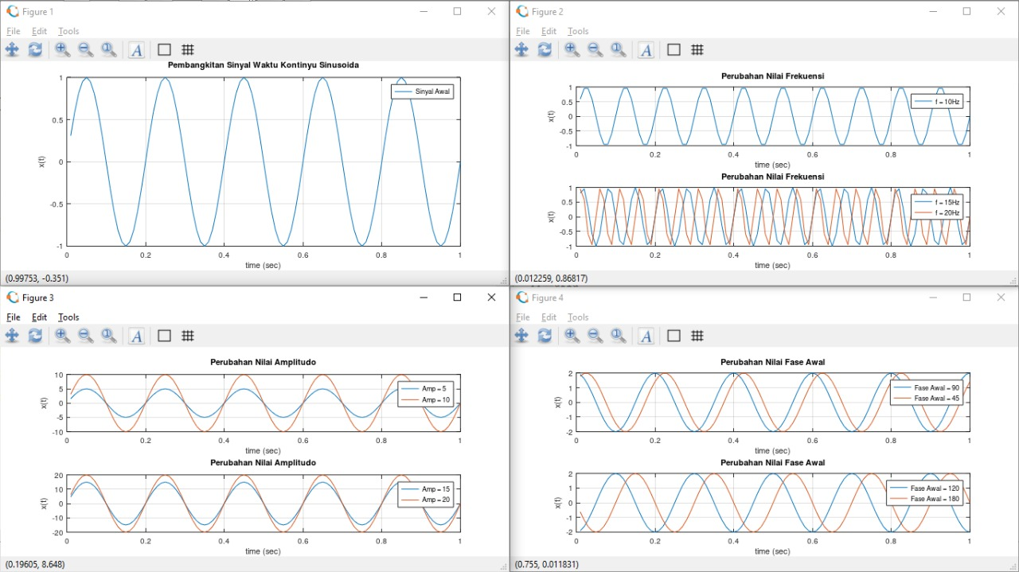

1. **Percobaan 2 : Pembangkitan Sinyal Waktu Kontinyu Persegi**

Program Editor :

pkg load signal

Fs=100;

t=(1:100)/Fs;

s1=square(2*pi*5*t);

s21=square(2*pi*10*t);

s22=square(2*pi*15*t);

s23=square(2*pi*20*t);

s31=square(2*(pi/4)*10*t);

s32=square(2*(pi*2/3)*15*t);

s33=square(2*(pi)*20*t);

s34=square(2*(pi*5/4)*10*t);

figure

plot(t,s1,'linewidth',2)

title('Pembangkitan Sinyal Waktu Kontinyu Persegi')

xlabel('time (sec)')

ylabel('x(t)')

legend('Sinyal Awal')

grid

axis([0 1 -1.2 1.2])

figure

subplot(2,1,1)

plot(t,s21,'linewidth',2)

title('Perubahan Nilai Frekuensi')

xlabel('time (sec)')

ylabel('x(t)')

legend('f = 10Hz')

grid

axis([0 1 -1.2 1.2])

subplot(2,1,2)

plot(t,s22,'linewidth',2, t,s23,'linewidth',2)

xlabel('time (sec)')

ylabel('x(t)')

legend('f = 15Hz','f = 20Hz')

grid

axis([0 1 -1.2 1.2])

figure

subplot(2,1,1)

plot(t,s31,'linewidth',2, t,s32,'linewidth',2)

title('Perubahan Nilai Fase Awal')

xlabel('time (sec)')

ylabel('x(t)')

legend('Fase Awal = 45','Fase Awal = 120')

grid

axis([0 1 -1.2 1.2])

subplot(2,1,2)

plot(t,s33,'linewidth',2, t,s34,'linewidth',2)

xlabel('time (sec)')

ylabel('x(t)')

legend('Fase Awal = 180','Fase Awal = 225')

grid

axis([0 1 -1.2 1.2])

Output Program :

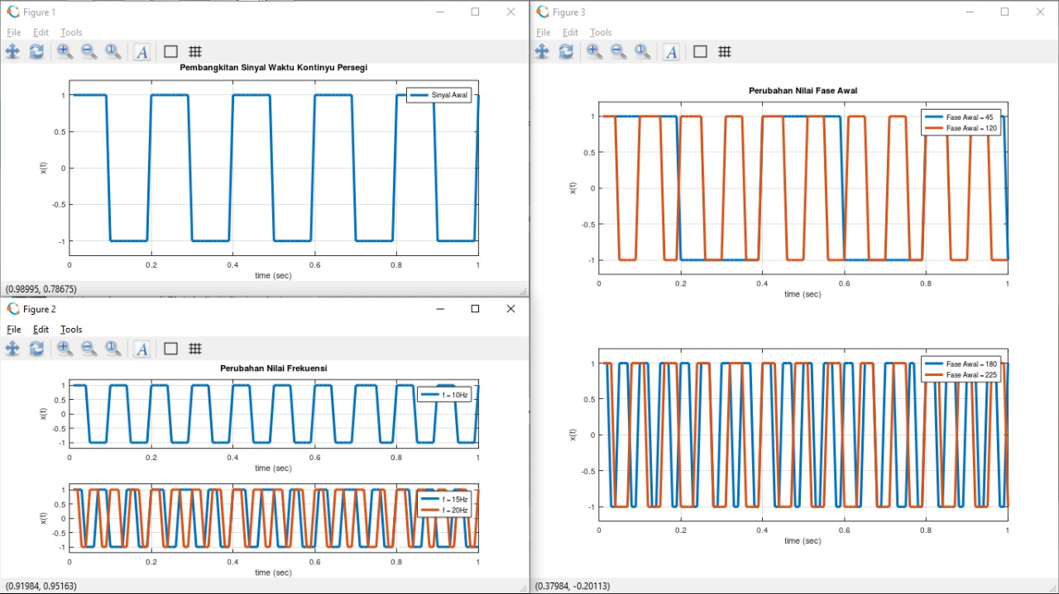

1. **Percobaan 3 : Pembangkitan Sinyal dengan Memanfaatkan file *.wav**

Program Editor :

y1 = audioread("114.wav");

Fs = 20000;

player = audioplayer(y1,Fs);

play(player);

plot(y1)

title('Pembangkitan Sinyal dengan Memanfaatkan File *.wav')

xlabel('Fs')

ylabel('Amplitudo')

legend('114.wav')

grid

Output Program :

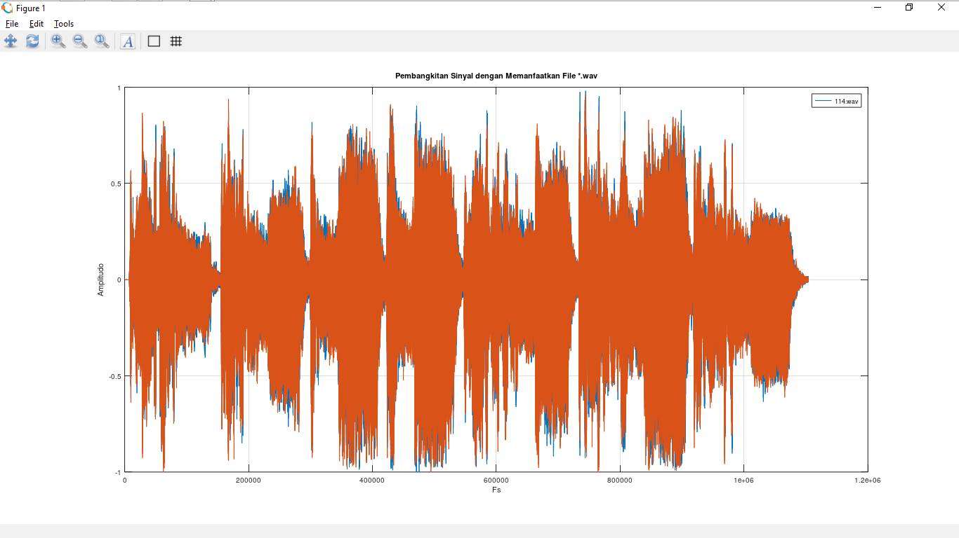

1. **Percobaan 4 : Pembangkitan Sinyal Kontinyu Fungsi Ramp**

Program Editor :

y(1:40)=1;

x(1:50)=[1:0.1:5.9];

x(51:100)=5.9;

t1=[-39:1:0];

t=[0:1:99];

plot(t1,y,'b',t,x,'linewidt',4)

title('Fungsi Ramp')

xlabel('Waktu (s)')

ylabel('Amplitudo')

grid

Output Program :

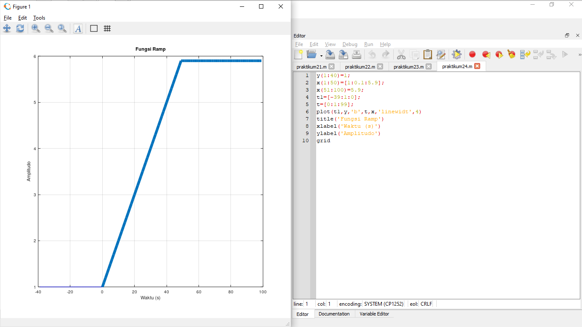

**TUGAS SELAMA PRAKTIKUM**

**Fungsi Unit Step**

Program Editor :

k = 0;

n1 = -5;

n2 = 5;

n = [n1:n2];

x = [ (n-k) >= 0];

stem(n,x);

title('Fungsi Unit Step')

xlabel('n')

ylabel('x(n)')

grid

Output Program :

